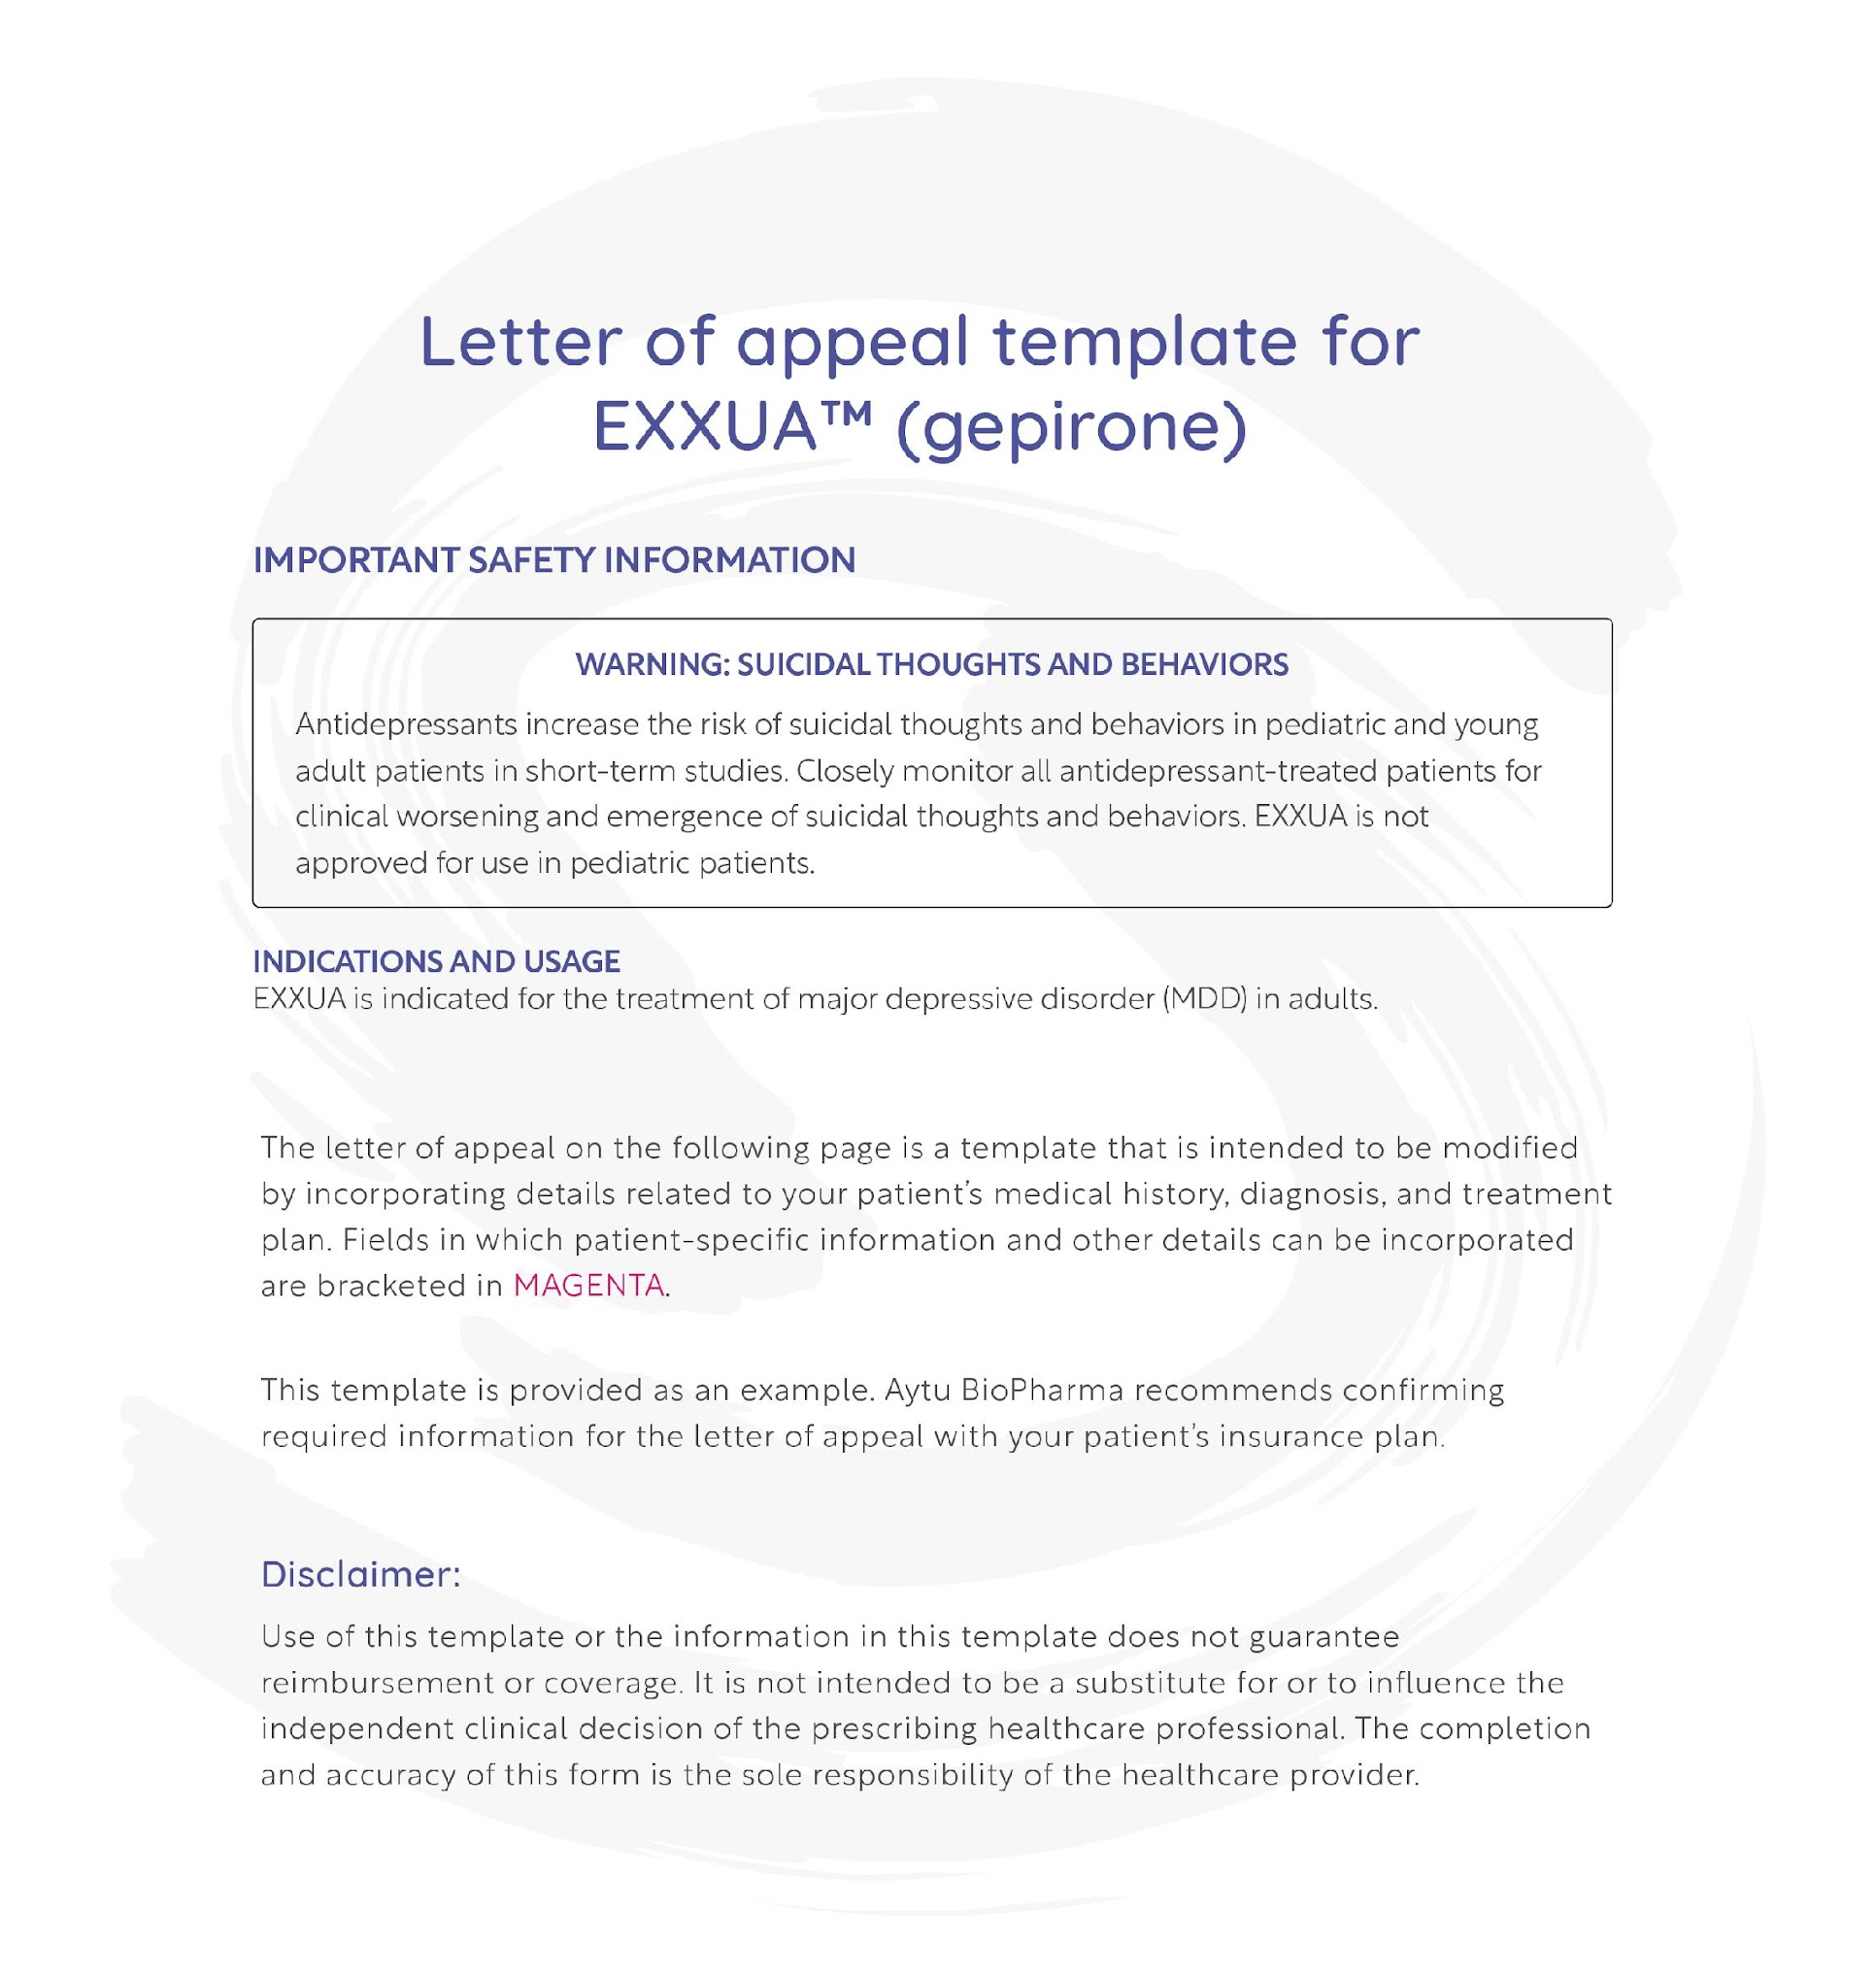 Please see additional Important Safety Information after the template.
Please click here for Full Prescribing Information for EXXUA.

[Your practice’s letterhead.]
[Date]
[Payer’s name]
[Payer’s address]
Attention: [Medical review/Appeals department]
RE: Denied claim for EXXUATM (gepirone)
Patient name: [Patient’s name]
Patient date of birth: [Patient’s date of birth]
Patient group/policy ID number: [Patient’s group/policy ID number]
Policyholder name: [Policyholder name]
Provider ID number: [Provider ID number]
Dear [Contact name/medical director]:

I am writing on behalf of my patient, [patient name], to appeal the denied claim they received for coverage of EXXUA, which is indicated for the treatment of adults with major depressive disorder (MDD).

I understand that the reason for your denial is [copy reason verbatim from the plan’s denial letter]. However, I believe that EXXUA is the appropriate and medically necessary treatment for my patient at this time. In support of my recommendation for treatment with EXXUA, I have provided an overview of my patient’s relevant clinical history below.
Summary of patient’s clinical history:
[Patient name] is [age] years old and was diagnosed with [patient’s diagnosis with ICD-10 code] on [date]. [Patient name] has been in my care since [date].

Relevant details of my patient’s clinical history are the following: [include a brief disease course of patient, including history of disease, symptoms, quality of life, functional impairments, and previous and current treatments (including dates of use, reasons for stopping). Additional information may include intolerable side effects, ongoing symptoms and conditions, changes in patient assessment of condition, and the patient’s inadequate or loss of response to other treatments. Consider referencing any relevant medical reports, test results, or clinical notes for support.]
Treatment plan and rationale:

In my clinical opinion, [patient’s name] should receive EXXUA for the following reasons:
[Present rationale for prescribing EXXUA using supporting research, medical treatment guidelines, and clinical evidence to substantiate the recommendation. Consider including potential risks that could be incurred by not starting the recommended treatment.]

Relevant documents listed below are enclosed, which offer additional support for the formulary exception request for EXXUA.

I hope you will reconsider coverage of EXXUA for my patient. If you have any questions, you can reach me at [phone number] or via email at [email address].
Thank you for your time and consideration.
Sincerely,
[Physician's signature]
[Physician's typed name and credentials]
Enclosures:
[List of enclosures, which may include: explanation of benefits/denial letter, original insurance claim form, letter of medical necessity, clinical notes, medical records, diagnostic test results, supportive research studies, EXXUA Prescribing Information]

IMPORTANT SAFETY INFORMATION

WARNING: SUICIDAL THOUGHTS AND BEHAVIORS

Antidepressants increase the risk of suicidal thoughts and behaviors in pediatric and young adult patients in short-term studies. Closely monitor all antidepressant-treated patients for clinical worsening and emergence of suicidal thoughts and behaviors. EXXUA is not approved for use in pediatric patients.

INDICATIONS AND USAGE
EXXUA is indicated for the treatment of major depressive disorder (MDD) in adults.

DOSAGE AND ADMINISTRATION

Important Recommendations Prior to Initiating and During Treatment with EXXUA
Electrocardiogram and Electrolyte Monitoring
Correct electrolyte abnormalities prior to initiating EXXUA. In patients with electrolyte abnormalities, or who are receiving diuretics or glucocorticoids, or who have a history of hypokalemia or hypomagnesemia, also monitor electrolytes during dose titration and periodically during treatment with EXXUA.
Perform an electrocardiogram (ECG) prior to initiating EXXUA, during dosage titration, and periodically during treatment. Do not initiate EXXUA if QTc is > 450 msec at baseline. Monitor ECGs more frequently if EXXUA is used:
- concomitantly with drugs known to prolong the QT interval
- in patients who develop QTc ≥ 450 msec during treatment
- in patients with a significant risk of developing torsade de pointes
Do not escalate the EXXUA dosage if the QTcF is > 450 msec.
Bipolar Disorder, Mania, and Hypomania Screening
Screen patients for a personal or family history of bipolar disorder, mania, or hypomania prior to initiating treatment with EXXUA.

Important Administration Instructions
Take EXXUA orally with food at approximately the same time each day. Swallow tablets whole. Do not split, crush, or chew EXXUA.
(Continued on next page)

IMPORTANT SAFETY INFORMATION (cont)
DOSAGE AND ADMINISTRATION (cont)

Recommended Dosage
The recommended starting dosage of EXXUA is 18.2 mg once daily. Based on clinical response and tolerability, the dosage may be increased to 36.3 mg orally once daily on Day 4 and further titrated to 54.5 mg orally once daily after Day 7 and to 72.6 mg orally once daily after an additional week. The maximum recommended daily dosage of EXXUA is 72.6 mg once daily.

Dosage Recommendations in Geriatric Patients
The recommended starting dosage of EXXUA in geriatric patients is 18.2 mg orally once daily. Based on clinical response and tolerability, the dosage may be increased to maximum recommended dosage of 36.3 mg orally once daily after Day 7.

Recommended Dosage in Patients with Renal Impairment
The recommended starting dosage of EXXUA in patients with creatinine clearance < 50 mL/min is 18.2 mg orally once daily. Based on clinical response and tolerability, the dosage may be increased to the maximum recommended dosage of 36.3 mg orally once daily after Day 7. The recommended dosage in patients with creatinine clearance ≥ 50 mL/min is the same as in patients with normal renal function.

Recommended Dosage in Patients with Hepatic Impairment
The recommended starting dose of EXXUA in patients with moderate (Child-Pugh B) hepatic impairment is 18.2 mg once daily. Based on clinical response and tolerability, the dosage may be increased to the maximum recommended dosage of 36.3 mg orally once daily after Day 7. EXXUA is contraindicated in patients with severe (Child-Pugh C) hepatic impairment. The recommended dosage in patients with mild (Child-Pugh A) hepatic impairment is the same as patients with normal hepatic function.

Dosage Modifications for Concomitant Use with CYP3A4 Inhibitors
Reduce the EXXUA dose by 50% when used concomitantly with a moderate CYP3A4 inhibitor. EXXUA is contraindicated in patients receiving strong CYP3A4 inhibitors.

Switching a Patient to or from a Monoamine Oxidase Inhibitor (MAOI) Antidepressant
At least 14 days must elapse between discontinuation of an MAOI intended to treat depression and initiation of therapy with EXXUA. Conversely, at least 14 days must be allowed after stopping EXXUA before starting an MAOI antidepressant.
(Continued on next page)

IMPORTANT SAFETY INFORMATION (cont)
CONTRAINDICATIONS
EXXUA is contraindicated in patients:
- with known hypersensitivity to gepirone or components of EXXUA.
- with prolonged QTc interval > 450 msec at baseline.
- with congenital long QT syndrome.
- receiving concomitant strong CYP3A4 inhibitors.
- with severe hepatic impairment.
- taking, or within 14 days of stopping, MAOIs due to the risk of serious and possibly fatal drug interactions, including hypertensive crisis and serotonin syndrome. Starting EXXUA in a patient treated with reversible MAOIs such as linezolid or intravenous methylene blue is also contraindicated.
WARNINGS AND PRECAUTIONS

Suicidal Thoughts and Behaviors in Adolescents and Young Adults
In pooled analyses of placebo-controlled trials of antidepressant drugs (SSRIs and other antidepressant classes) that included approximately 77,000 adult patients, and 4,500 pediatric patients, the incidence of suicidal thoughts and behaviors in antidepressant-treated patients aged 24 years and younger was greater than in placebo-treated patients.
There was considerable variation in risk of suicidal thoughts and behaviors among drugs, but there was an increased risk identified in young patients for most drugs studied. There were differences in absolute risk of suicidal thoughts and behaviors across the different indications, with the highest incidence in patients with MDD.
*EXXUA is not approved for use in pediatric patients.
Monitor all antidepressant-treated patients for clinical worsening and emergence of suicidal thoughts and behaviors, especially during the initial few months of drug therapy, and at times of dosage changes. Counsel family members or caregivers of patients to monitor for changes in behavior and to alert the healthcare provider. Consider changing the therapeutic regimen, including possibly discontinuing EXXUA, in patients whose depression is persistently worse, or who are experiencing emergent suicidal thoughts or behaviors.
(Continued on next page)

IMPORTANT SAFETY INFORMATION (cont)
WARNINGS AND PRECAUTIONS (cont)

QT Prolongation

EXXUA prolongs the QTc interval.
- EXXUA is contraindicated in patients with congenital long QT syndrome and in patients with severe hepatic impairment or in patients receiving concomitant strong CYP3A4 inhibitors as they increase EXXUA plasma concentrations.
- Do not initiate EXXUA if QTc is > 450 msec at baseline.
- Correct electrolyte abnormalities prior to EXXUA initiation. In patients with electrolyte abnormalities, who are receiving diuretics or glucocorticoids, or have a history or hypokalemia or hypomagnesemia, also monitor electrolytes during dose titration and periodically during treatment with EXXUA.
- Perform an ECG prior to EXXUA initiation, during dosage titration, and periodically during treatment. Monitor patients with ECGs more frequently:
    - If EXXUA is used concomitantly with drugs known to prolong the QT interval.
    - In patients who develop QTc ≥ 450 msec during treatment with EXXUA. Do not escalate the EXXUA dosage if QTcF is > 450 msec.
    - In patients with a significant risk of developing torsade de pointes, including those with uncontrolled or significant cardiac disease, recent myocardial infarction, heart failure, unstable angina, bradyarrhythmias, uncontrolled hypertension, high degree atrioventricular block, severe aortic stenosis, or uncontrolled hypothyroidism.
- Reduce the EXXUA dosage when used concomitantly with moderate CYP3A4 inhibitors, as they may increase EXXUA concentrations.

Serotonin Syndrome
Concomitant use of EXXUA with SSRIs or tricyclic antidepressants may cause serotonin syndrome, a potentially life-threatening condition with changes including altered mental status, hypertension, restlessness, myoclonus, hyperthermia, hyperreflexia, diaphoresis, shivering, and tremor. The concomitant use of EXXUA with MAOIs is contraindicated. In addition, do not initiate EXXUA in a patient being treated with MAOIs such as linezolid or intravenous methylene blue. If it is necessary to initiate treatment with an MAOI such as linezolid or intravenous methylene blue in a patient taking EXXUA discontinue EXXUA before initiating treatment with the MAOI.
(Continued on next page)

IMPORTANT SAFETY INFORMATION (cont)
WARNINGS AND PRECAUTIONS (cont)

Serotonin Syndrome (cont)
If concomitant use of EXXUA with other serotonergic drugs is clinically warranted, inform patients of the increased risk for serotonin syndrome and monitor for symptoms. Discontinue EXXUA and/or concomitant serotonergic drug immediately if the above symptoms occur and initiate supportive symptomatic treatment.

Activation of Mania or Hypomania
Antidepressant treatment can precipitate a manic, mixed, or hypomanic manic episode. The risk appears to be increased in patients with bipolar disorder or who have risk factors for bipolar disorder. Prior to initiating treatment with EXXUA, screen patients for a history of bipolar disorder and the presence of risk factors for bipolar disorder (e.g., family history of bipolar disorder, suicide, or depression). EXXUA is not approved for use in treating bipolar depression.
ADVERSE REACTIONS
Most common adverse reactions (incidence of ≥5% and at least twice incidence of placebo) were dizziness, nausea, insomnia, abdominal pain, and dyspepsia.
The following adverse reactions are discussed in greater detail in other sections of the labeling:
- Suicidal Thoughts and Behaviors in Adolescents and Young Adults
- QT Prolongation
- Serotonin Syndrome
- Activation of Mania or Hypomania

To report SUSPECTED ADVERSE REACTIONS, contact Aytu BioPharma at 1-855-298-8246 or http://www/exxua.com or FDA at 1-800-FDA-1088 or www.fda.gov/medwatch.

USE IN SPECIFIC POPULATIONS

Pregnancy
The background risk of major birth defects and miscarriage for the indicated population is unknown. In the U.S. general population, the estimated background risk of major birth defects and miscarriage in clinically recognized pregnancies is 2 to 4% and 15 to 20%, respectively.
(Continued on next page)

IMPORTANT SAFETY INFORMATION (cont)
USE IN SPECIFIC POPULATIONS (cont)
Pregnancy (cont)
There is a pregnancy exposure registry that monitors pregnancy outcomes in women exposed to antidepressants, including EXXUA, during pregnancy. Healthcare providers are encouraged to register patients by calling the National Pregnancy Registry for Antidepressants at 1-866-961-2388 or visiting online at https://womensmentalhealth.org/research/pregnancyregistry/antidepressants/.
Lactation
There is no data on the presence of gepirone in human milk, the effects on the breastfed infant, or the effects on milk production. Gepirone is present in rat milk. When a drug is present in animal milk, it is likely that the drug will be present in human milk. There are reports of breastfed infants exposed to other serotonergic antidepressants experiencing irritability, restlessness, excessive somnolence, decreased feeding, and weight loss. The developmental and health benefits of breastfeeding should be considered along with the mother’s clinical need for EXXUA and any adverse effects on the breastfed infant from EXXUA or from the underlying maternal condition.

OVERDOSAGE
In clinical studies, cases of acute ingestions up to 454 mg (6.25 times the maximum recommended dose) of EXXUA alone or in combination with other drugs, were reported. Signs and symptoms reported with overdose of EXXUA at doses up to 454 mg included vomiting and transient incomplete bundle branch block; an unknown dose of EXXUA produced altered level of consciousness and a 60-second convulsion. No specific antidotes for EXXUA are known. Consider contacting the Poison Help line
(1-800-222-1222) or a medical toxicologist for additional overdose management recommendations.
Please click here for Full Prescribing Information for EXXUA.
